Preparation of Papers for International Journal of Systematic Innovation

Abstract
These instructions give you guidelines for preparing manuscripts for International Journal of Systematic Innovation. Use this document as a template if you are using Microsoft Word 2000 or later. Paper titles should be written in uppercase and lowercase letters, and should be concise and informative. Full names of authors should be provided. Department names are optional in the affiliations. Do not give street addresses in the affiliations (except for authors with no institutional affiliation). Manuscripts should be written in English. Abstracts not more than 200 words for a full paper outlining the scope and contributions of the paper are required.
Keywords: Keywords should be given and placed below the abstract. About four key words or phrases in alphabetical order, separated by commas.

Introduction
This document is a template for Microsoft Word versions 2000 or later. If you are reading an html version of this document, please save it as a Word file so that you can use it to prepare your manuscript.

Type
Prepare your articles use the A4 template, margins: top = 25mm, bottom = 30mm, side = 20mm. Times New Roman is the preferred font. This template provides two levels for written articles: 1. Title 2, 1.1 Title 3. The author can use (1), (2), (3), …, → a., b., c., …, if necessary.

2.1 Figures and tables
Figure captions should be centered below the figures. Avoid placing figures before their first mention in the text. Full size of the figure (100%) is suggested. Use “Fig. 1”, “Fig. 2” without “.” after number when mentioning the figure in the text.
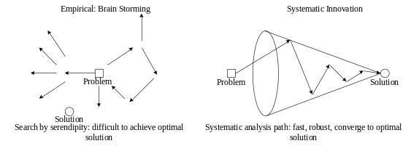
Fig. 1 This is an example of a figure caption.
Table captions should be centered above. Avoid placing tables before their first mention in the text. Full size of the figure (100%) is suggested. Use “Table 1”, “Table 2” no “.” preceded or appended to number when mentioning the figure in the text.
Table 1 This is an example a table caption.
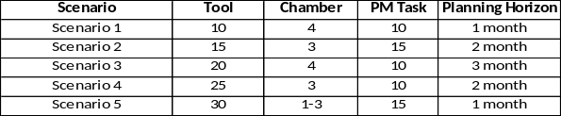

2.2 Units and equations
The submitted manuscripts must use SI (Metric) Units in text, figures, or tables.
Define abbreviations and acronyms the first time they are used in the text, even if they have been defined in the abstract. Abbreviations such as SI, MKS, CGS, do not have to be defined. Abbreviations that incorporate periods should not have spaces: write “C.N.R.S.,” not “C. N. R. S.” Do not use abbreviations in the title unless they are unavoidable.
All mathematical expressions and formulas should be typewritten. All symbols should be clearly defined. Number equations consecutively with equation numbers in parentheses flush with the right margin, as in Eq. (1). Punctuate equations when they are part of a sentence, as in
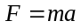 (1)
Be sure that the symbols in your equation have been defined before the equation appears or immediately following. Italicize symbols, such as “m is the mass of the object.” Refer to the equations as “Eq. (1)” in the text.

2.3 References (APA style)
References should be cited in the text by giving the last name of the author(s) and the year of publication of the reference, such as “The work (Bellman and Zadeh, 1970)...” or “Bellman and Zadeh (1970) had ...”. With three or more names use the form “Hsu et al. (1995)” in the text. When two or more references have the same text identification, please distinguish them by appending “a”, “b”, etc., to the year of publication.
References should be listed in alphabetical order, according to the last name of the first author, at the end of the paper. References should include the complete name of authors (Last name/ Family name and initials of First name/ Given name), the complete title(s), journal name or publisher name, publish year, the number of the volume and the page(s) of the information cited. The common format of Reference is Last name, initials of First name. (publication year). Title of Book. place of publication, publisher. For instance, Note: the underlined title is just for understanding, not included in formal paper.

Book
Sheu, D. D. (2011). Mastering TRIZ innovation tools: Part I. Agitek Consulting.
Mann, D. L. (2007). Hands-On Systematic Innovation, 2nd Ed, IFR Press.

List author name (Last name first and then initials for given names), year of publication with parenthesis, title of the book (only first word capitalized, and so as the subtitle), place of publication, and publisher. In the publisher’s name omit the names of Publishing, Company, and Inc., but give a full name: Agitek Consulting; Longman; HarperCollins.
Or, reference with the same author in the same year are alphabetized and marked with lowercase letters—a, b, c—immediately after the date.
Sheu, D. D. and Hou, C. T. (2011a). Self-closing Embedded Slit Valve, R.O.C. Patent pending.
Sheu, D. D. and Hou, C. T. (2011b). Self-closing Embedded Slit Valve, U.S.A. Patent pending.
Journal
Sheu, D. D. (2007). Body of knowledge for classical TRIZ, the TRIZ Journal, 1(4), 27-34.

List author name(s), year of publication with parenthesis, title of the article without quotation marks, name of the journal italicized and with all major words capitalized, volume number italicized, inclusive page number not preceded by “p.” or “pp.”
Magazine
List author, the date of publication—year, month without abbreviation, title of the article without quotation mark, name of the magazine in italics with all major words capitalized, and inclusive page if you do not have volume number. If a magazine prints the article on discontinuous pages, include all page numbers.
Kokmen, L. (2008, March / April). Environmental justice for all. Utne, 42-46.

Unpublished paper in Conference
Sheu, D. D., Tsai, E, and Rau, H, (2012). Integration between Cause-effect Chain Analysis and Root Contradiction Analysis and Its Applications, the 3rd International Conference on Systematic Innovation, Seoul, South Korea.
Sheu, D. D. and Tsai, M. C. (2012). Cause Effect and Contradiction Chain Analysis for conflict Identification and Problem Solving, the 2nd International Conference on Systematic Innovation.

List author(s), year, title of the article italicized, conference name, and location of conference.

Internet Source
OxfordCreativity. (2012). Retrieved from: http://www.oxfordcreativity.com
Li S., The Harm Concerning Occupation Drummers. Retrieved November 9, 2006, from http:// www.dagoo.com.tw/teach/ professionalHarm01.php
Hudson, R. G. (2007). The empirical basis to skepticism. Minerva: An International Journal of Philosophy. Retrieved September 22, 2008, from http:// www.mic.ul.it/stephen/vol11/Skepticism.html
University of Illinois at Chicago, Health Research and Policy Centers. (2008) Partners with tobacco use research centers: Advancing transdisciplinary science and policy studies. Retrieved from the Robert Wood Johnson Foundation Web site: http:// www.rwjf.org/portfolios/resources/grant.jsp?id=039787&iaid_143
List website name, the year of publication, website link preceded by Retrieved from:

References should be listed in alphabetical order, according to the last name of the first author, at the end of the paper. If you’d like to know more information of reference, you may refer to Writing Research Papers: A Complete Guide by Lester.

